**IOT MICRO PROJECT**

**TITLE:** **CONTACTLESS DOOR BELL**

**PROBLEM SCENARIO:**

* Year 2020 has taught us many things. Our lifestyle has changed and we have adopted to many new and safe ways of livelihood.
* From social distancing to working from home, our main aim these days is to stay safe and avoid touching unnecessary objects.
* This prototype will protect you from the germs which others leave on your doorbell.
* This project is an attempt to make a simple touchless bell, without spending a lot from your pocket.

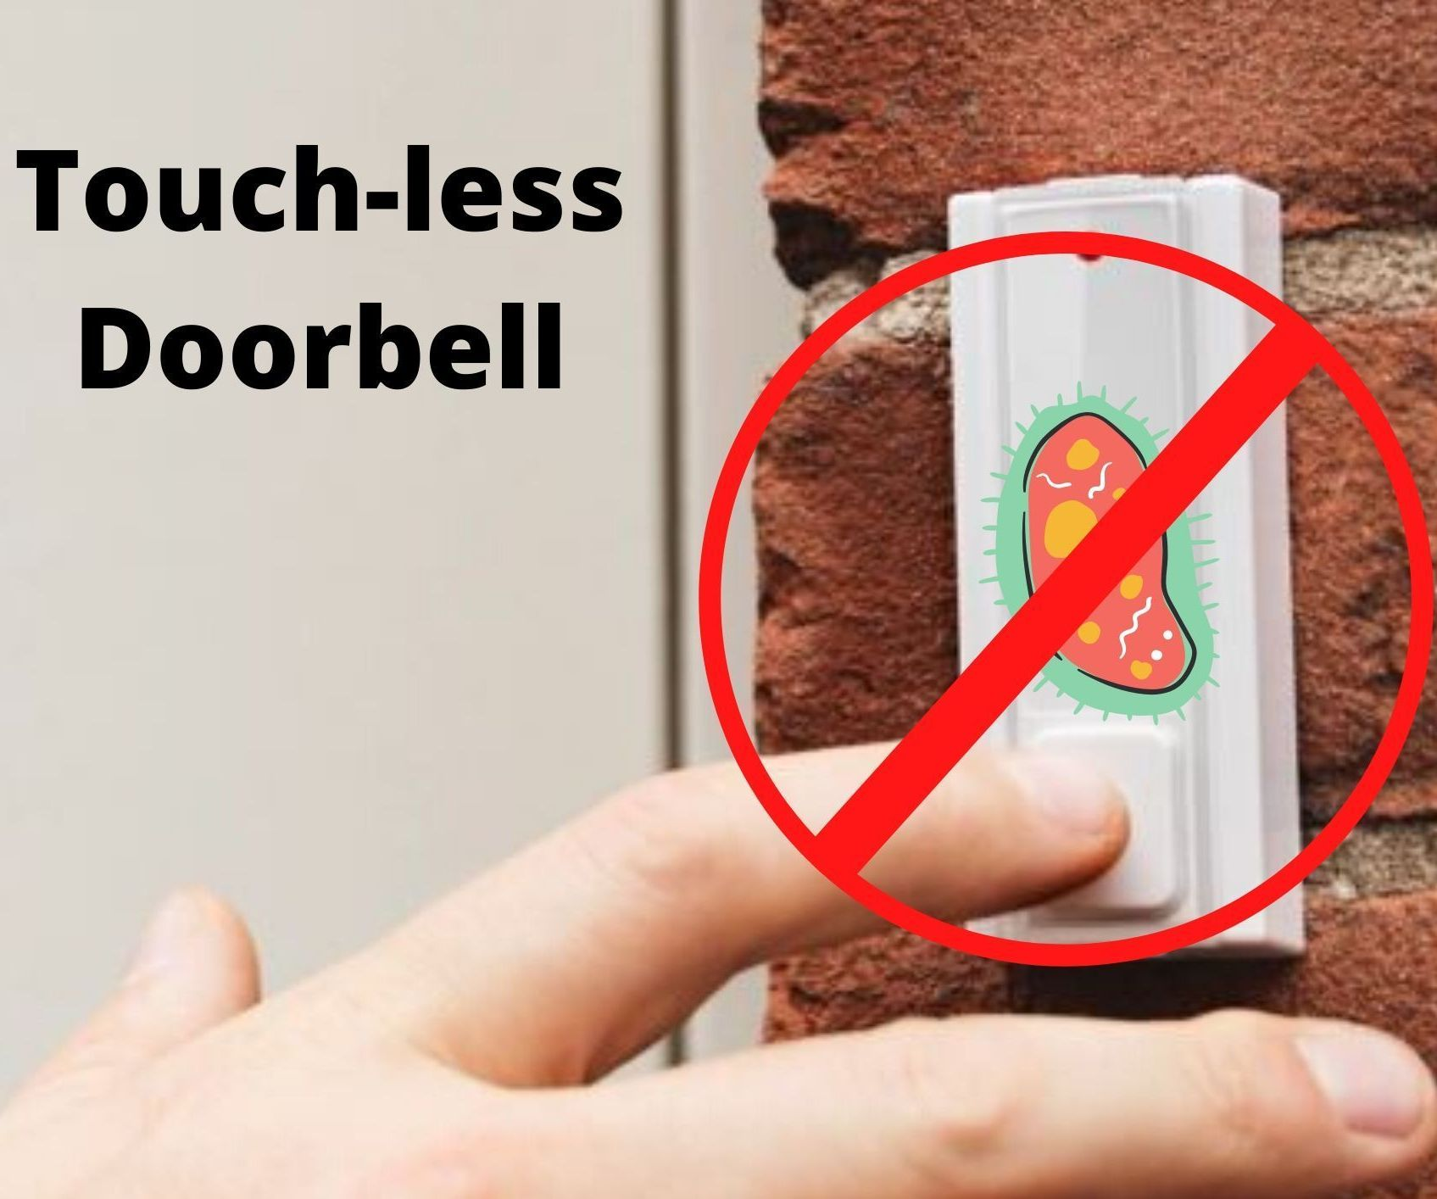

* The above kind of usage of door bell may leave the deadly corona virus germs on the switch when the outsiders visits our home.
* Ex: Delivery guys, guests, neighbours and family members.
* As it may leads to many health issues. So, this kind of door bell usage avoidance will help everyone.

**SOLUTION :**

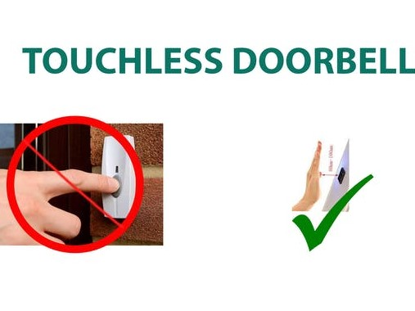

* The above picture describes how our project is going to be implemented.
* Instead of touching the bell switch it’s just gives the buzz or any sound by placing the hands in front of the prototype.
* The prototype mainly working with the **IR SENSOR** and with a **BUZZER.**
* We think it is the most efficient way to protect ourselves from the deadly coronavirus or any other kind of germs.

**COMPONENTS REQUIRED:**

Our project consists of the following components.

1. Arduino Uno or Nano
2. Breadboard
3. IR Sensor Module
4. LED
5. Buzzer
6. Jumper Wires

**DESCRIPTION:**

1. Arduino Uno

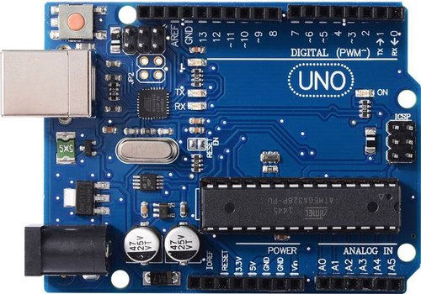

Arduino refers to an open-source electronics platform or board and the software used to program it. Arduino is designed to make electronics more smartly accessible.

1. Breadboard

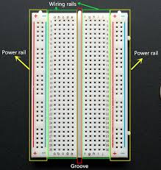

A breadboard is a solderless device for temporary prototype with electronics and test circuit designs.

1. IR Sensor Module

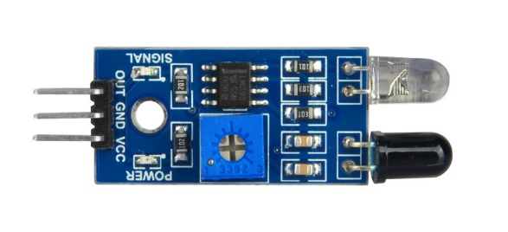An infrared (IR) sensor is an electronic device that measures and detects infrared radiation in its surrounding environment.

Working Principle:

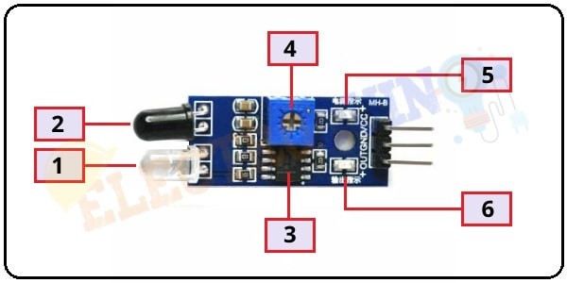

The IR Sensor mainly consists of

1. IR Transmitter

2.Photodiode Receiver

3. LM393 Comparators IC

4. Variable Resistor (Trim pot)

5. Power LED

6. Output LED.

An Infrared Sensor works in the following sequence:

1. IR source (transmitter) is used to emit radiation of required wavelength.
2. This radiation reaches the object and is reflected back.
3. The reflected radiation is detected by the IR receiver.
4. The IR Receiver detected radiation is then further processed based on its intensity. Generally, IR Receiver output is small and amplifiers are used to amplify the detected signal.
5. Typical working of IR sensor detection system can be understood by Figure 2 below.

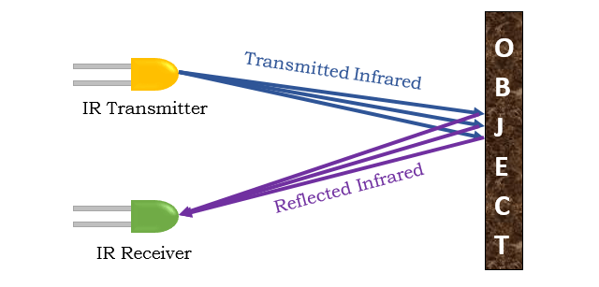

1. LED

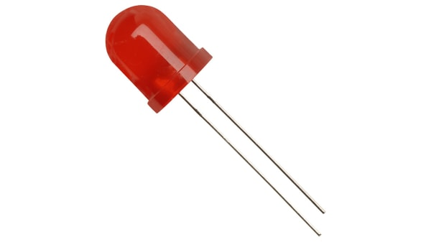

A light-emitting diode (LED) is a semiconductor light source that emits light when current flows through it.

1. Buzzer

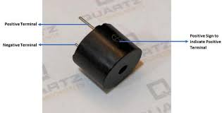

A buzzer or beeper is an audio signalling device, which may be mechanical, electromechanical, or piezoelectric.

1. Jumper Wires

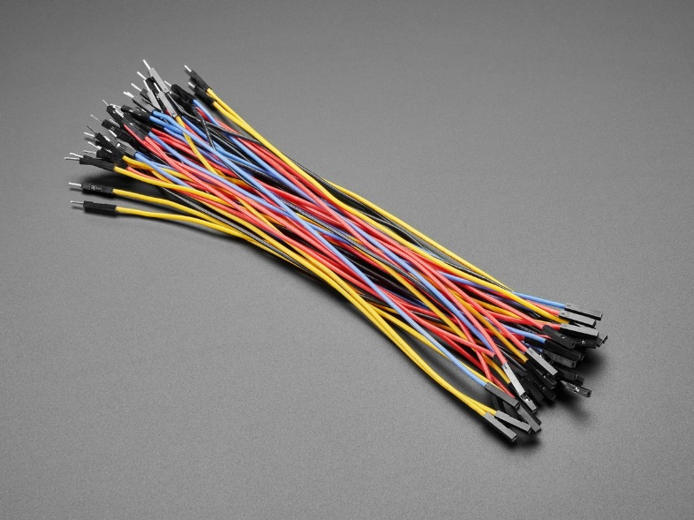

A jump wire is an electrical wire, or group of them in a cable, with a connector or pin at each end which is normally used to interconnect the components of a breadboard or other prototype.

**BLOCK DIAGRAM**:

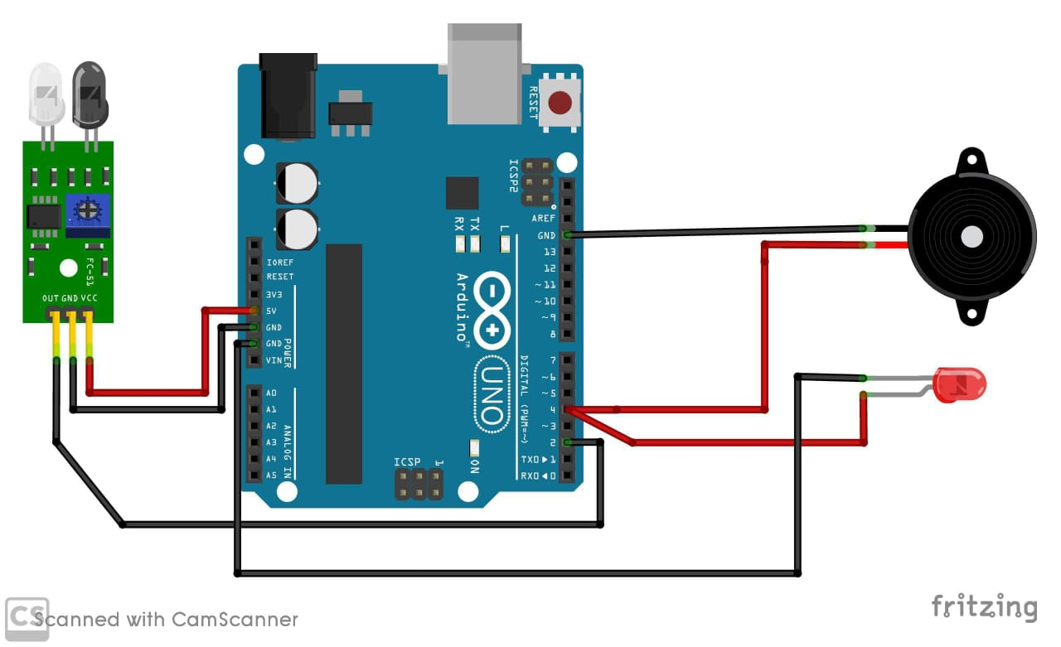

**PROCEDURE:**

1.Insert the IR sensor in the breadboard.

2.Take the 1st jumper wire and connect both the ends to the breadboard.

3.Take 2nd jumper wire and connect one end to the ir sensor and the other end to the ground of breadboard.

4. Take 3rd jumper wire and connect one end to the breadboard and the other end to the pin number 2 of the arduino uno.

5.Now connect the buzzer to the ground of the breadboard.

6.Connect 4th jumper wire with one end to the buzzer and other end to the pin number 4 of the 7.Take the 5th jumper wire and connect one end to the breadboard and other end to the Vcc of the arduino uno.

8.Finish the connections by connecting LED to the ground of the breadboard.



The above video shows the connections. It has the procedure of connecting all the required components in a step by step manner.

**CODE:**

//MAX TECHNICAL 360

#define IR 2

#define buzzer 4// digital pin for ir sensor

#define buzzer 4

int detection = LOW; // initialization to no obstacle

void setup() {

Serial.begin(9600); // used for communication between the Arduino serial port and a PC

pinMode(IR, INPUT);

pinMode(buzzer, OUTPUT);

}

void loop() {

detection = digitalRead(IR);

if(detection == LOW){

digitalWrite(buzzer,HIGH);

}

else{

digitalWrite(buzzer,LOW);

}

delay(500); }

**\*NOTE:**

As we are working with Arduino Uno when we open the Arduino IDE, go to tools and select Arduino Uno.

**OUTPUT:**

* After writing the code and uploading it in the Arduino Uno, your prototype will be ready to get the output.
* When an object comes close to the IR sensor, the infrared light from the LED is turned on and it is detected by the receiver so that the buzzer gives out the buzz sound.



**PHOTOS:**

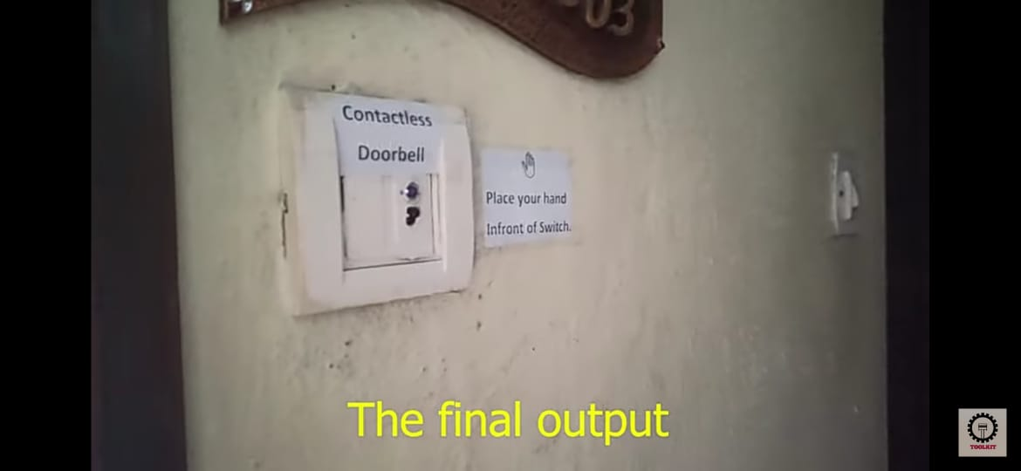

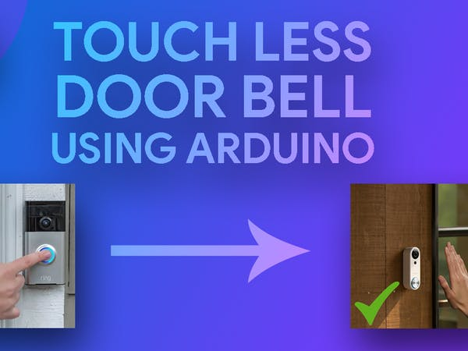

PRESENTED BY:

19R01A05J8 – BANDARU THANMAI

19R01A05J9 – CHINNAGARI PAVANI

19R01A05K5 – GOPIDI VAISHNAVI

THANK YOU